1. UPPER, LOWER, INITCAP
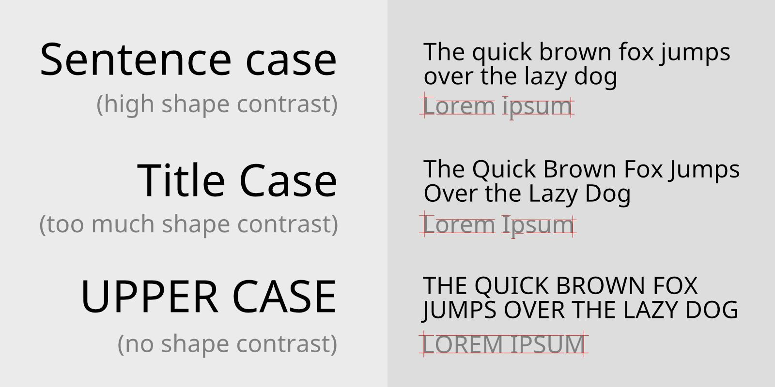

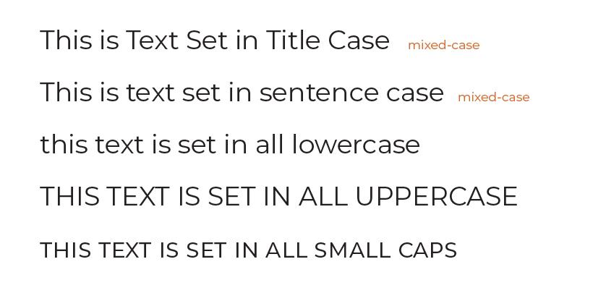
5
UPPER() → convert text to CAPITAL letters
SELECT UPPER('Amazing Postgres SQL');
Output:
AMAZING POSTGRES SQL

LOWER() → convert text to small letters
SELECT LOWER('Amazing Postgres SQL');
Output:
amazing postgres sql

INITCAP() → first letter capital (Title Case)
SELECT INITCAP('welcome to postgres sql');
Output:
Welcome To Postgres Sql

Example with table
SELECT
UPPER(first_name),
LOWER(last_name),
INITCAP(first_name || ' ' || last_name) AS full_name
FROM directors;

2. LEFT() and RIGHT()
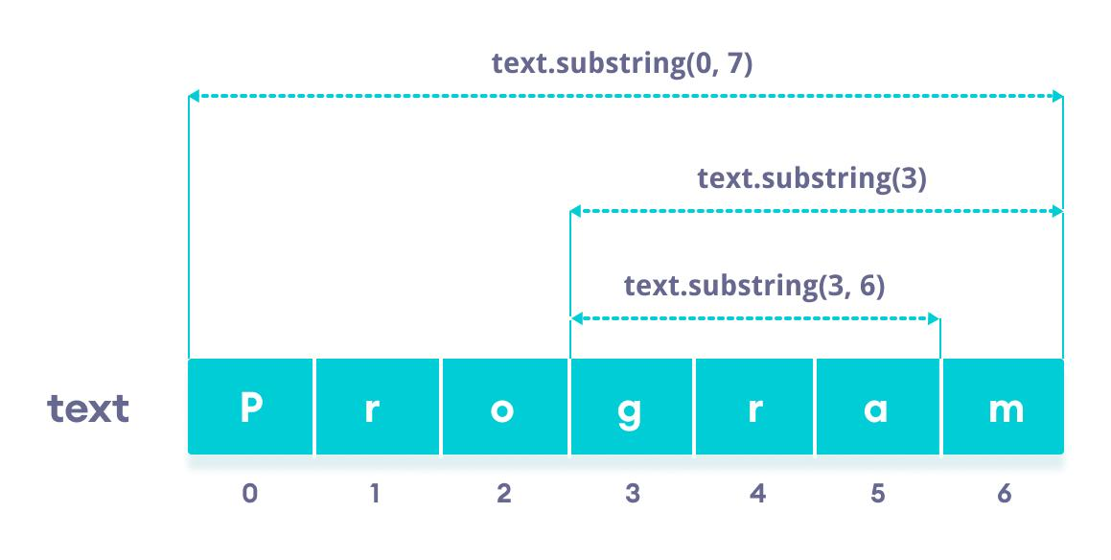
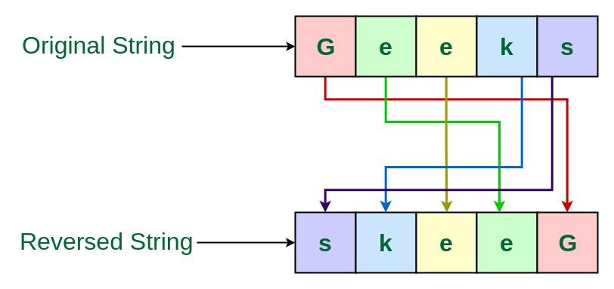

4
LEFT(string, n)
returns first n characters
SELECT LEFT('ABCD',2);
Output:
AB

RIGHT(string, n)
returns last n characters
SELECT RIGHT('ABCD',2);
Output:
CD

Negative values
LEFT with negative → removes characters from end
SELECT LEFT('ABCD',-1);
Output:
ABC
RIGHT with negative → removes characters from start
SELECT RIGHT('ABCD',-1);
Output:
BCD

Example
Get initials of directors:
SELECT LEFT(first_name,1) AS initial
FROM directors;

3. REVERSE()
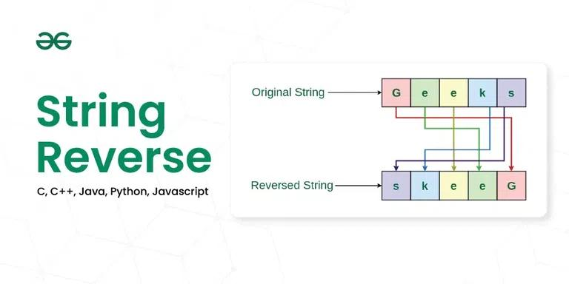
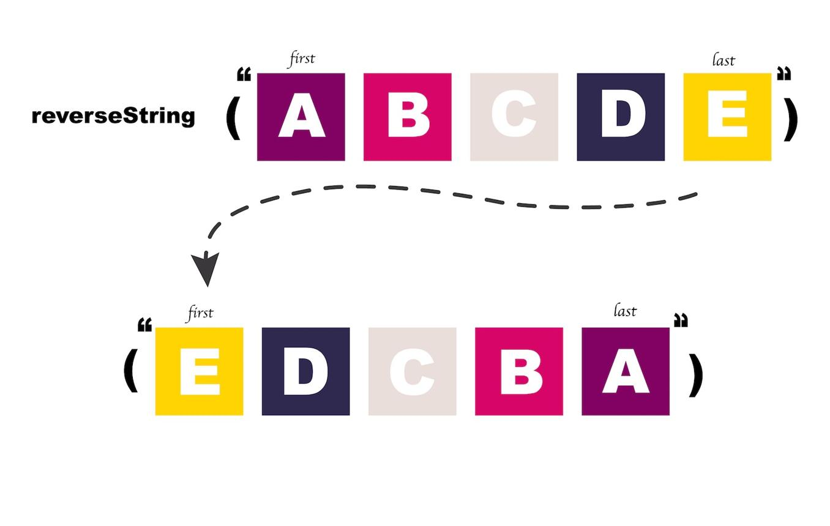

5
Reverses string
SELECT REVERSE('ABCDE');
Output:
EDCBA

4. SPLIT_PART()
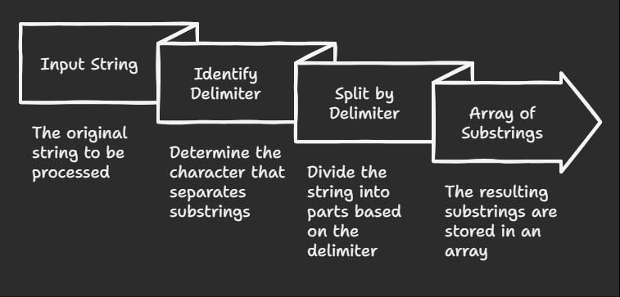
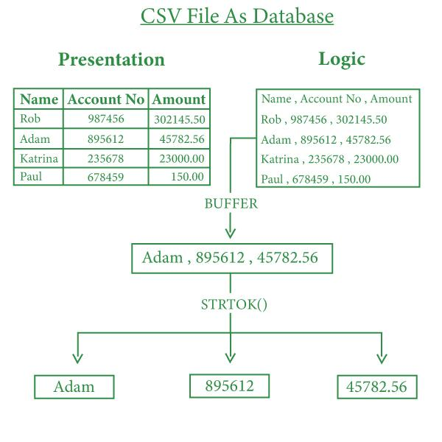
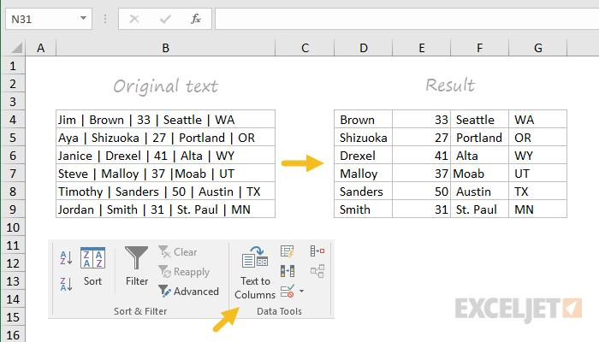
5
Splits string using delimiter and returns part
Syntax:
SPLIT_PART(string, delimiter, position)
Example:
SELECT SPLIT_PART('apple,banana,mango', ',', 2);
Output:
banana

Extract year from date
SELECT SPLIT_PART('2025-04-20','-',1);
Output:
2025

5. TRIM, LTRIM, RTRIM, BTRIM
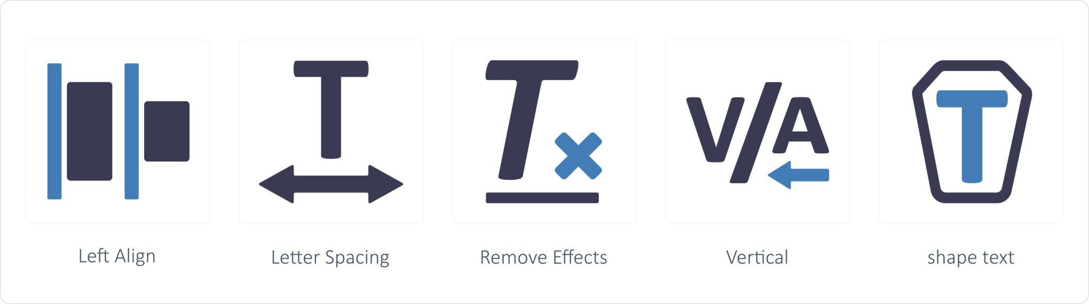
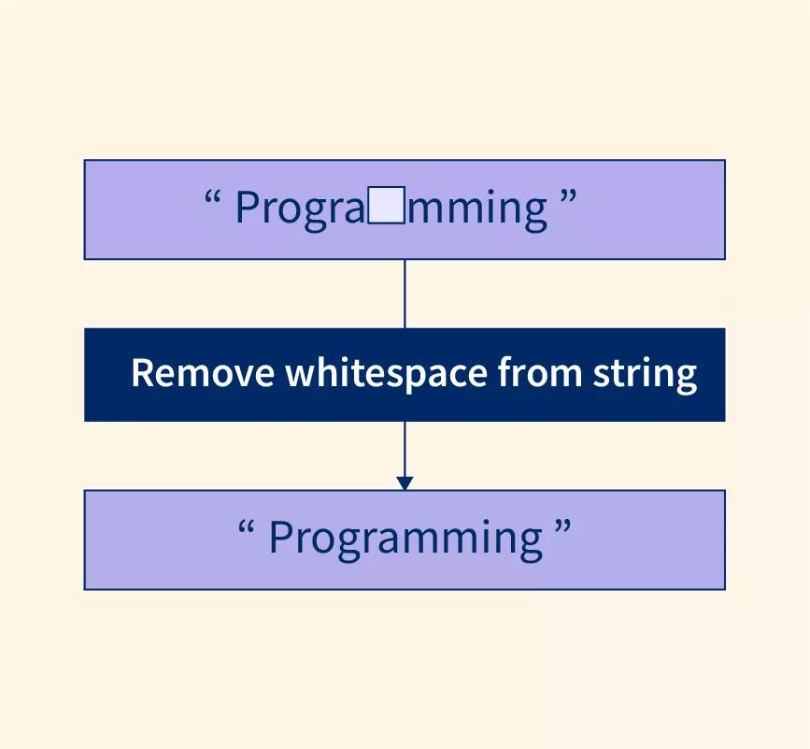
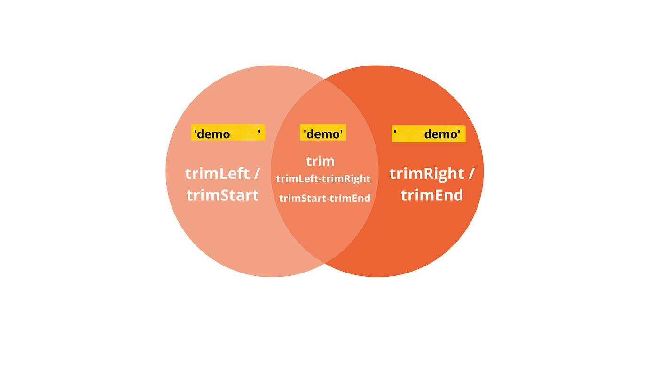
6
Used to remove unwanted characters (usually spaces)

TRIM()
removes spaces both sides
SELECT TRIM(' hello ');
Output:
hello

LTRIM()
remove left spaces
SELECT LTRIM(' hello');
Output:
hello

RTRIM()
remove right spaces
SELECT RTRIM('hello ');
Output:
hello

remove specific character
SELECT TRIM(LEADING '0' FROM '000123');
Output:
123

6. LPAD and RPAD
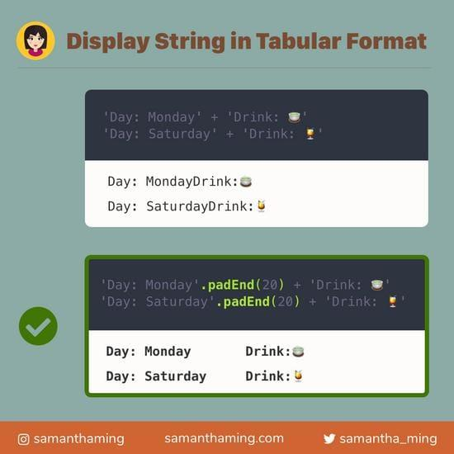
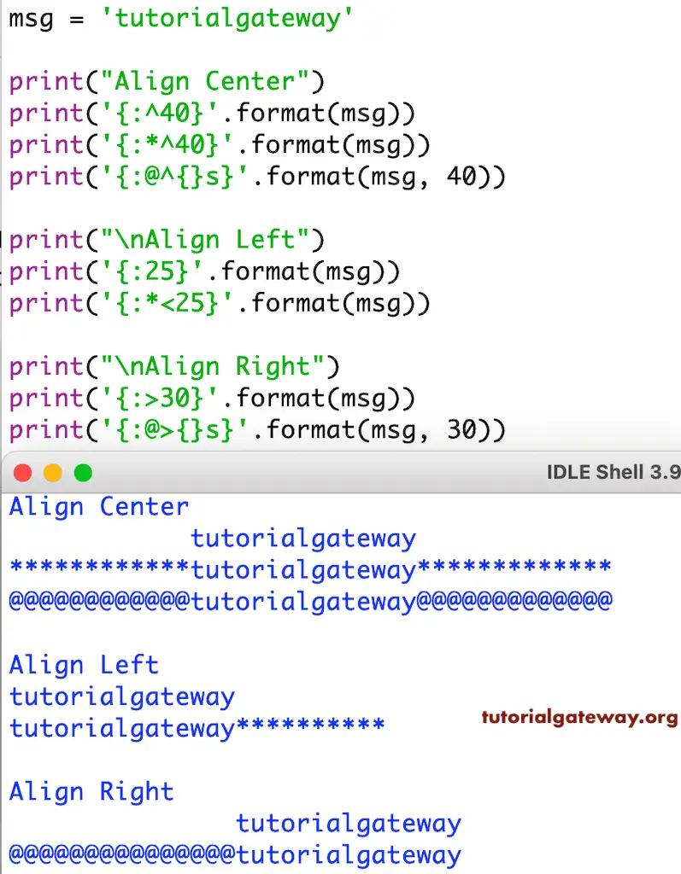
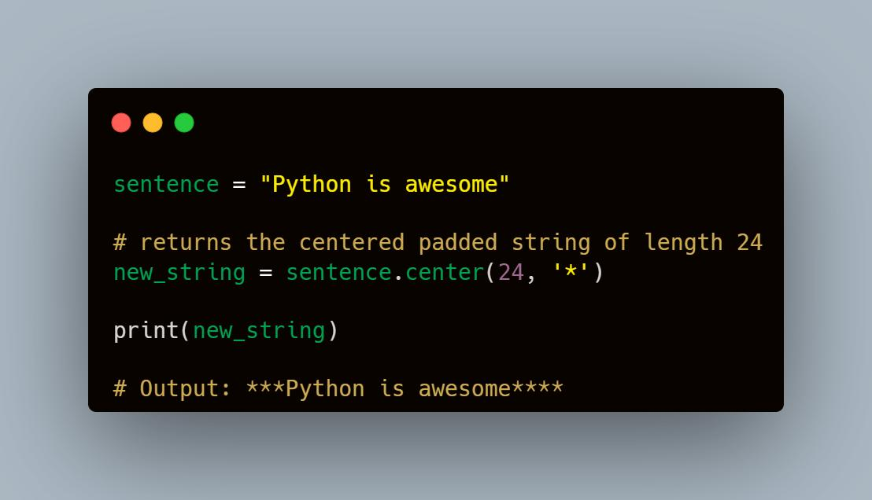
6
Adds characters to reach fixed length.

LPAD()
adds characters to left
SELECT LPAD('SQL',6,'*');
Output:
***SQL

RPAD()
adds characters to right
SELECT RPAD('SQL',6,'*');
Output:
SQL***

7. LENGTH() / CHAR_LENGTH()
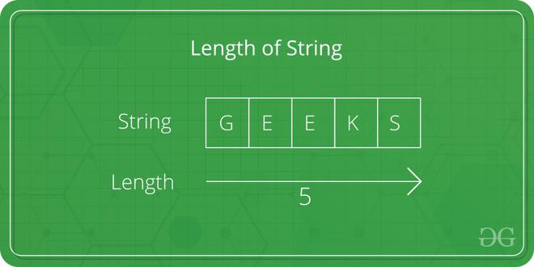
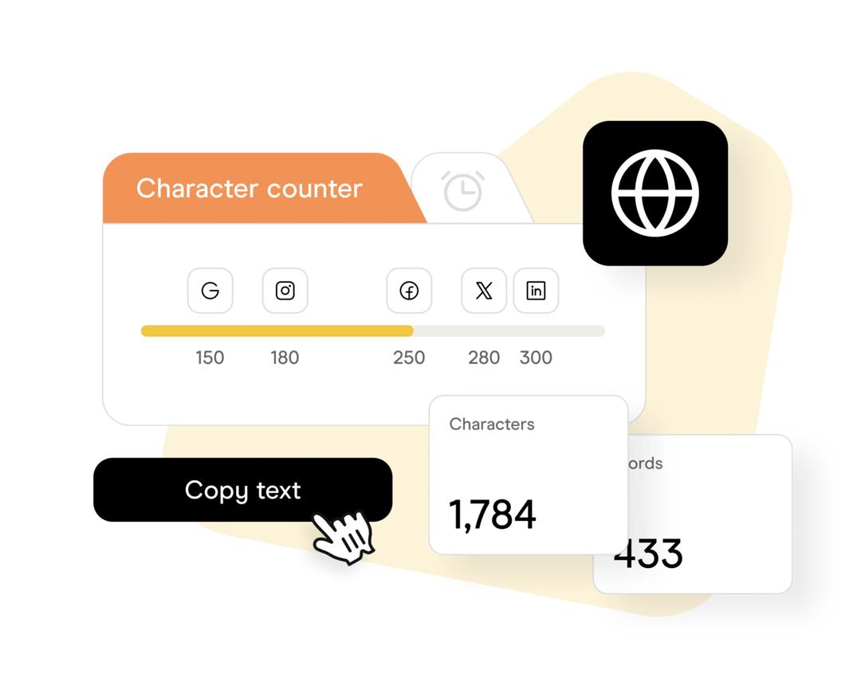
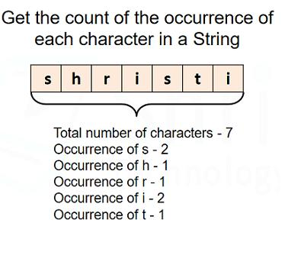
5
Counts number of characters
SELECT LENGTH('Postgres');
Output:
8

Example:
SELECT
first_name,
LENGTH(first_name)
FROM directors;

8. POSITION() and STRPOS()
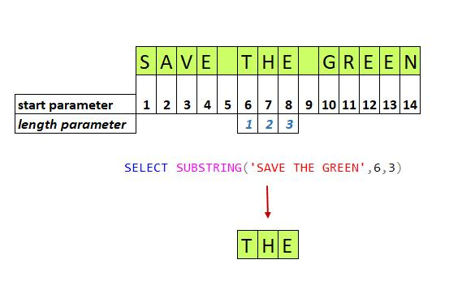
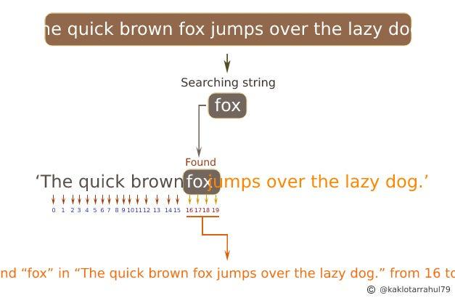
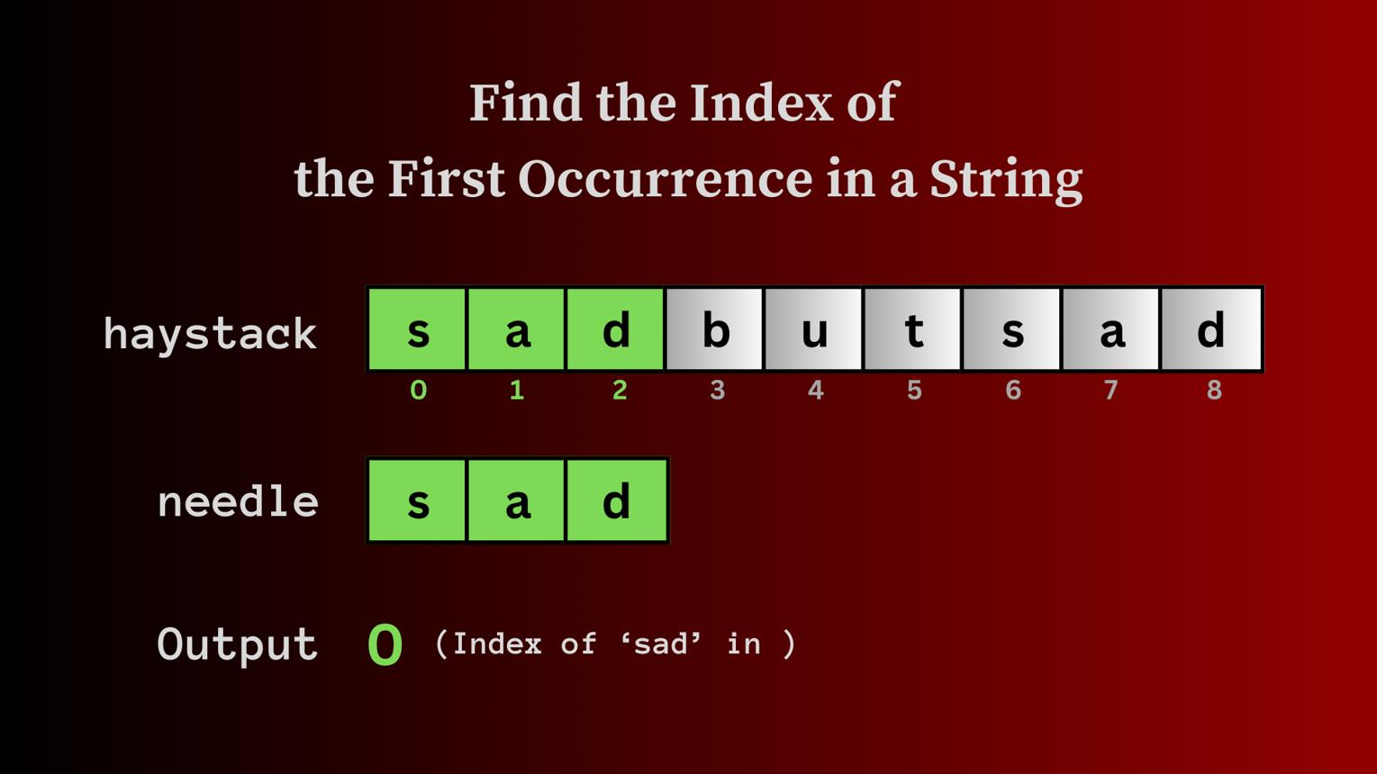
5
Find position of substring
SELECT POSITION('SQL' IN 'PostgreSQL');
Output:
9

Alternative function:
SELECT STRPOS('PostgreSQL','SQL');
Both same result.

9. SUBSTRING()
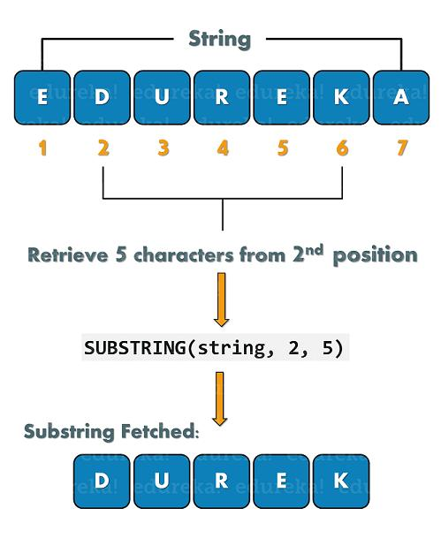

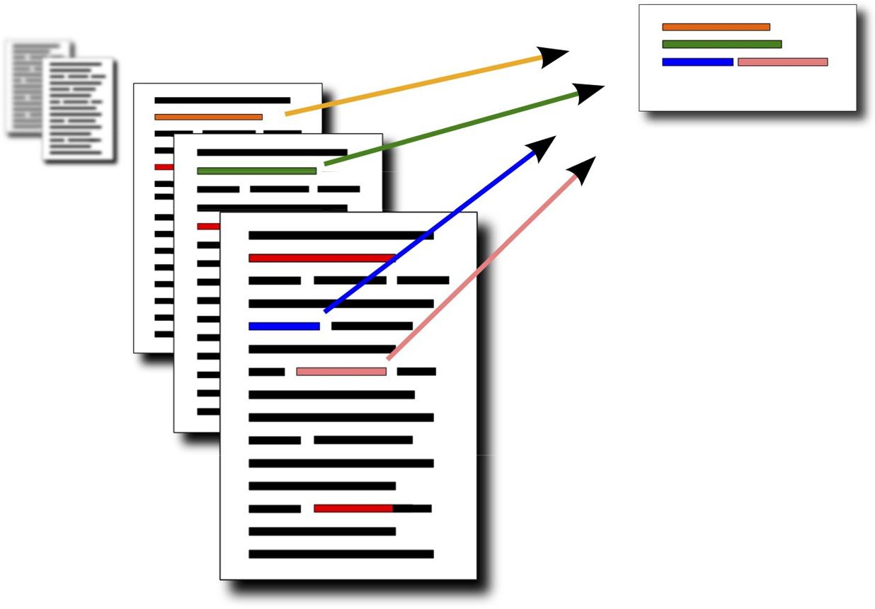
5
Extract part of string
Syntax:
SUBSTRING(string FROM start FOR length)
Example:
SELECT SUBSTRING('PostgreSQL' FROM 1 FOR 4);
Output:
Post

10. REPEAT()
Repeats string multiple times
SELECT REPEAT('A',5);
Output:
AAAAA

11. REPLACE()
Replace word with another
SELECT REPLACE('I like cats','cats','dogs');
Output:
I like dogs

Replace all occurrences:
SELECT REPLACE('121212','2','9');
Output:
191919

Quick Summary Table
Function | Use
UPPER | convert to CAPITAL
LOWER | convert to small
INITCAP | First letter capital
LEFT | first characters
RIGHT | last characters
REVERSE | reverse text
SPLIT_PART | split string
TRIM | remove spaces
LPAD | add left characters
RPAD | add right characters
LENGTH | count characters
POSITION | find word index
SUBSTRING | extract part
REPEAT | repeat text
REPLACE | replace text

